- The first file is called main.tf, which terraform treats as an entry point for your build. This file contains all the resource information that you need in your Azure environment.
- The second file is variables.tf which stores the list of input variables that you will use in the main.tf file. The idea here is to not hardcode any values in the main file.
- The third file, for now, would be terraform.tfvars. This is optional, however, recommended if you are working with the terraform for the first time. Ideally, you should never check out this file to your source control as this file is used to define what values you want to pass on for all the input variables and it may contain sensitive information.
- One last thing that I would not address here is the terraform.tfstate file. This file contains sensitive information about your environment built using terraform and ideally should be stored in secure storage, like Azure Storage Containers. However, we'll cover the remote backend in the upcoming articles.
Reference: https://parveensingh.com/terraform-in-action-with-azure/#prerequisites

variable "resource_group_name" {
description = "The prefix which should be used for all resources in this example"
default = "rg-idp-int"

terraform.tfstate
{
"version": 4,
"terraform_version": "1.1.6",
"serial": 1,
"lineage": "8a076b7d-15d9-ada6-2a0f-a1fa22951215",
"outputs": {},
"resources": []
}
----------------------

- Terraform init
- Terraform plan
- Terraform apply
- Terraform destroy – only run if to undo.
To deploy infrastructure with Terraform:
- Scope - Identify the infrastructure for your project.
- Author - Write the configuration for your infrastructure.
- Initialize - Install the plugins Terraform needs to manage the infrastructure.
- Plan - Preview the changes Terraform will make to match your configuration.
- Apply - Make the planned changes.

Track your infrastructure
Terraform keeps track of your real infrastructure in a state file, which acts as a source of truth for your environment. Terraform uses the state file to determine the changes to make to your infrastructure so that it will match your configuration.

To set subscription
Az account set --subscription “ Name of subscription”

For azureDevOP
backend" "azurerm" {
resource_group_name = "tosinafeez-infra"
storage_account_type = "tosinafeeztstate"
container_name = "tstate"
key = "QzZsgvtgfVWXtOv56UqLY91SH9XzP+u/B9rsaYhfPoInYUpt7GPcmOj8EVa1NQ5lmw4HUvh0lqdxIlAKgq3czg=="
}

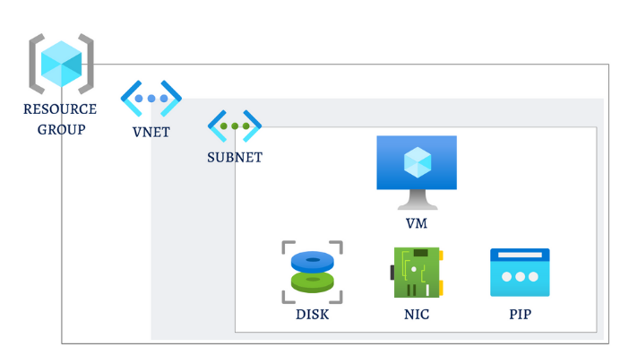

Infrastructure as code (IaC) tools allow you to manage infrastructure with configuration files rather than through a graphical user interface. IaC allows you to build, change, and manage your infrastructure in a safe, consistent, and repeatable way by defining resource configurations that you can version, reuse, and share.

Also, it's worth mentioning that the var.resource_group_name and the value in the resource line resorucegroup01 are not linked at all. Think of the first one as what you get in Azure and the second one is simply used to reference the terraform resource inside the file. Whenever there is a dependency of resources on one another, you always reference the components using terraform resource name, not the variable name.
resource "azurerm_resource_group" "resourcegroup01" {
name = var.resource_group_name
location = var.location
}

- -dry-run - Report all of the resource instances that match the given address without actually "forgetting" any of them.
Terraform -dry-run will list all the command and their use case.

Command: state rm | Terraform | HashiCorp Developer

Terraform – Azure deployment.
Azure DevOps Pipelines with Terraform and Stages (youtube.com)

Deploying Azure Infrastructure With Terraform Using Azure DevOps Pipelines / Blogs / Perficient

Automate the Automation PART 3: Setup an Azure DevOps Pipeline using Terraform (youtube.com)

resource_group_name: AGTerraform-infra
storage_account_name: agterraformtstate
container_name: tstate
access_key: HCXJ2JcIticgDwjJMsMRV6erDO8VutMwTxgwIPTaEj+0PE4XqMy5pkYhKSJZDPWmrpVbFoIB9KGT+AStRrxILw==

Using for_each in Terraform to Create Multiple Unique Azure VMs | Map of Objects (youtube.com)

